Chart 1: Suicide Rate per 100000 inhabitants

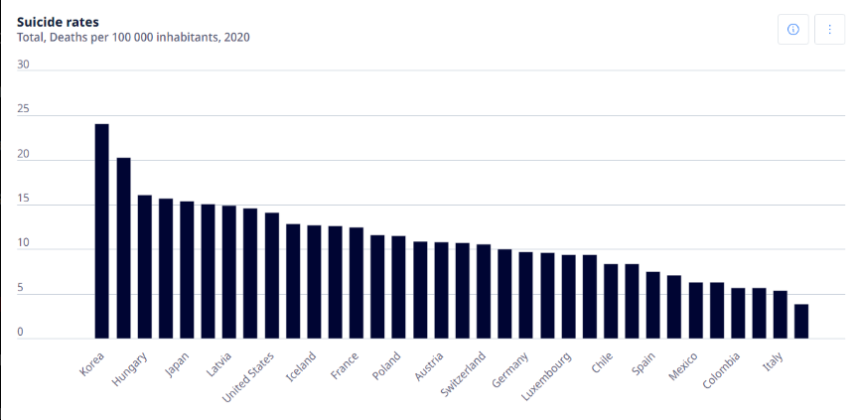

Figure 1. Picture of a chart of Suicide Rates.

This visualization shows suicide rate which lead to casualties per 100000 inhabitants on the year 2020 at multiple countries. This bar chart visualizations have several design flaws which will hinder and lower the charts effectiveness.

Firstly, this chart had the inconsistent labelling issue, in the x-axis of this chart, the countries names are not uniformly aligned. Some of the country take two columns, some of them overlaps other columns. This inconsistency of labelling will lead to visual confusion which confuses the viewer and will take them a lot of time to understand the data. Not only that, this inconsistency will also lead to misinterpretation of data especially for those who are only doing a quick glance through the data.

Secondly, its visual simplicity and viewer engagement, this chart is overly simplified in a way that it doesn’t engage audiences. The colour scheme used in the chart are uniform with no variations and had a basic bar chart presentation which might seem boring to many viewer.

With just a little modifications, this chart can look better and attract more audience, such as adding different colour scheme for values that are vastly different from the other data. For example, adding red colour for bars with extreme values or outliers.

Thirdly, its data granularity and precision are lacking. The chart had simplified its data presentation to whole number such as the multiple of fives on its y-axis, which do not show subtle change in the value properly, causing time-consuming confusion for viewer.

Fourthly, its accessibility concerns. This chart does not follow the best practices of accessibility design as it only uses colour alone to present its data, without using any other method such as incorporating symbols such as warning signs to warn them about something or the use of textures and patterns. This issue will cause dissatisfaction for people with colour vision deficiency. Not only that, the font size used for the country’s names are small and hard to be read, especially for those who are using smaller devices such as a tablet or a smartphone.

Fifthly, its scale and proportion issue. The scale of the chart might not properly show the range of data. For example, when then value of a bar in the data are having a huge difference with the rest of the data, other bar will be shrunk to fit the extreme value, making the chart to look weird. This issue can be solved with proper dynamic scaling method such as breaking the chart into two sections and with a rift or crack symbol in between, indicating there is a huge value gap in between the two sections.

With all of these issues addressed, the chart can be conveying its message clearer and make more viewer engaged. Hence, helping viewers to produce powerful insights for their tasks.

Chart 2: Life Expectancy After the Age of 65 Years Old

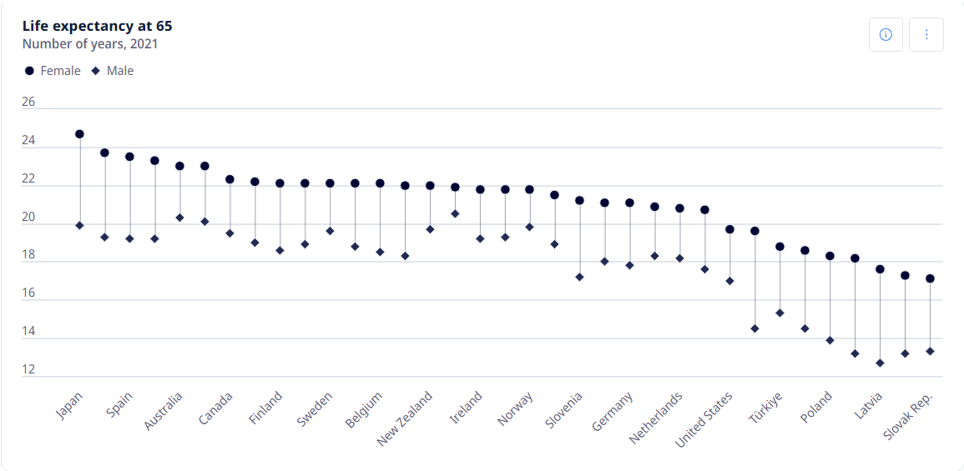

Figure 2. Picture of a chart of Life Expectancy After the Age of 65 Years Old.

This data visualization shows that life expectancy of people across multiple countries after the age of 65 years old. This chart contains data of both male and female and are separated with different symbols of circle and diamond. This visualizations have several design flaws which will hinder and lower the charts effectiveness.

Firstly, the primary issue of the chart is its clarity and readability, the clustering of data makes it hard for viewer to find their data at first glance. The x-axis of the data is overlapping with each other as they are close packed together, making it difficult for viewer to distinguish between each data, leading to misinterpretation of data. To solve this issue, the chart could have bigger spacing in between the bars or even writing the countries names in vertical line to ensure a uniform spacing.

This modification can remove the overlapping issue and increase readability.

Secondly, the colour and design of this chart are less interesting and are unable to attract viewers attentions. The uniform colour palette currently used by the chart does not have the capability to describe the differences in the data, which might cause difficulties for some viewer to properly identify the difference in the data. This issue can be solved by using variation in colours to the different type of data. For example, they can use colour red for female data and colour blue for male data. This modification can enhance the visual appearance of the overall chart and decrease the difficulties of the viewer to understand the chart, as the chart had highlighted all its important information.

Thirdly, the chart is not optimized for multiple formats. The chart is only optimized for computers but not smaller devices such as smartphones, they data might look a bit disproportionate if viewed on a smaller device such as the details might be compressed and lose its accurateness. To solve this issue, a multi-format optimization strategies can be implemented, which involves designing a chart with ability to adjust its size dynamically according to the change in resolution.

Fourthly, its accessibility issue. This chart uses similar shape and colour to differentiate between the male and female data, which causes difficulties in reading data for people with visual impairments. This issue can be solved with additional labelling options such as a small “M” in the shape for male, and a small “F” in the shape for female. This small modification can ensure even the viewer with visual impairment can properly read the data and come up with insights for their tasks.

These changes will help to make the chart clearer and more engaging to the viewer, and help deliver the message of which country has the highest life expectancy after 65 years old, and which countries are suitable for retirement life.

Chart 3: Alcohol Consumption (Litres per person)

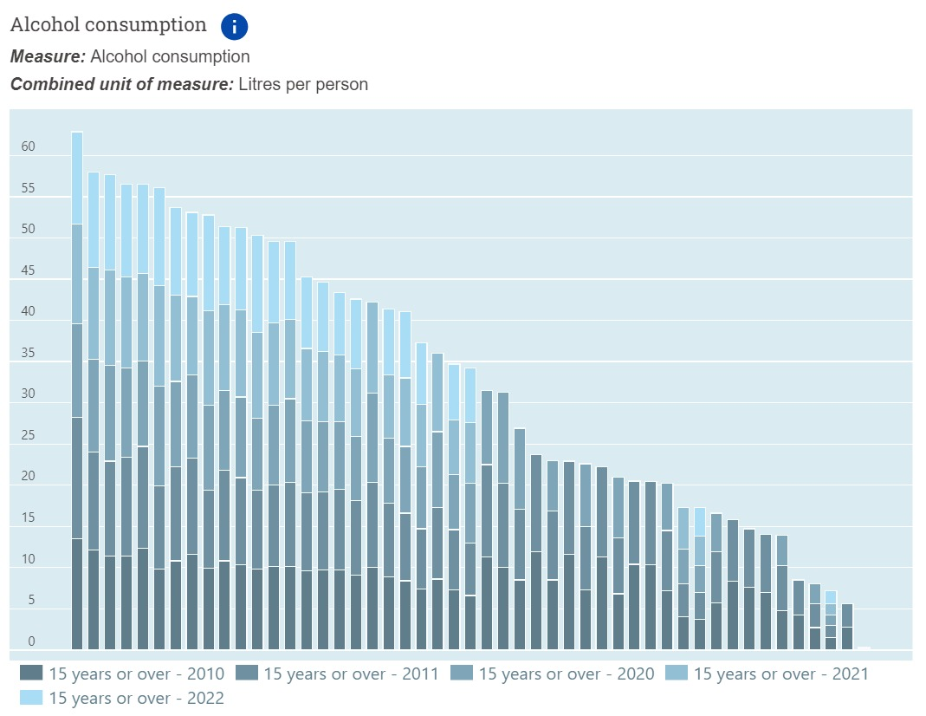

Figure 3. Picture of an Alcohol Consumption bar chart.

This stacked bar chart is showing the data of alcohol consumption of age 15 and over for the year 2010, 2011, 2020, 2021 and 2022. Each of the years are separated with bars of different colours.

This chart had several flaws in its design as well, firstly, Clarity and legibility issue, as this graph is filled with bars overlapping each other for data for different years. Which makes it hard for viewer to identify the trends over the year and causes confusion for viewer as well. Not only that, some of the bar might overlap other bar completely when the data are the same, making disappearance of some data.

Secondly, its colour differentiation and design, the chart uses different shades of blue across the whole chart, such as its background is the lightest shade of blue and darker shades of blue are used for the bars to represent different years in the chart. This design will make it difficult for people with colour visual impairment to read the data, they might not be able to differentiate the different shades of blue, or might not see the difference between the shades of blue. Thus, hampering their decision making. To solve this issue, different colour which contrast each other can be used such as black and white, white and blue or incorporate the use of pattern and textures into the bar chart, such as using dotted patterned bar.

Thirdly, its data representation issue, the x-axis that’s supposed to have countries name are not present due to the limited space between each bar. These issue causes viewer confusion when reading the chart.

Fourthly, its contextual information Is lacking as no insights of the chart is offered, which require viewer to spend more time to gained their own insights from the chart. To solve this issue, the chart can incorporate a brief analysis that will explain the trends such as the increase and decrease of the alcohol consumption over the years.

Fifthly, its data density and information overload issue, the chart is designed in a way that it displays too much information at once, which leads to information overload. This issue will affect many of the users who are not familiar with huge amount of data at once, and make it difficult for them to derive insights from the chart. This issue can be solved with simplifying the presentation of the chart by grouping the data into categories, such as by geographic regions. For example, grouping the data of alcohol consumption of the Asia continent and take its average as the data on the chart, and providing options to switch to a more detailed version that shows all the data from different countries in Asia.

Sixthly, adding a comparative analysis can solve the difficult data comparison issue from the data. The chart currently had no easy way to help viewer compare data from different years, viewer had to scroll around to different year on the chart to find the data and compare it themselves. Hence, making quick decision-making task very difficult. To solve this issue, a comparison tool that can quickly calculate the differences between alcohol consumption of each year and different countries had to be developed.

By modifying all of the issue, this chart can be made to be clearer and provide better insight for decision making, helping viewer to complete their task at a faster pace and less confusion.

**References**

Few, S. (2009). *Now You See It: Simple Visualization Techniques for Quantitative Analysis*. Analytics Press.

Norman, D. (2013). *The Design of Everyday Things: Revised and Expanded Edition*. Basic Books.

Rothman, K. J., Greenland, S., & Lash, T. L. (2008). *Modern Epidemiology* (3rd ed.). Wolters Kluwer Health/Lippincott Williams & Wilkins.

Web Accessibility Initiative (WAI). (2021). *Web Content Accessibility Guidelines (WCAG)*. W3C.

Siegel, E. (2016). *Predictive Analytics: The Power to Predict Who Will Click, Buy, Lie, or Die*. Wiley.